j0437958j0437958

*This certifies that*

Claire Mitchell

*Has participated fully in the 5-day course*

### “Analyzing, Interpreting, and Presenting Microbiome and Resistome Data”

*June 17 – 21, 2024*

*Presented by the* *****Centre for Veterinary Epidemiological Research***** *at the Atlantic Veterinary College*

*University of Prince Edward Island*

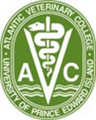

Paul Morley, DVM PhD DACVIM

Professor, Research Director

VERO Program

Texas A&M University



Noelle Noyes, DVM PhD MA

Associate Professor

College of Veterinary Medicine

University of Minnesota